**Wire Shark – SMTP and ICMP**

* **SMDP WIRE SHARK**

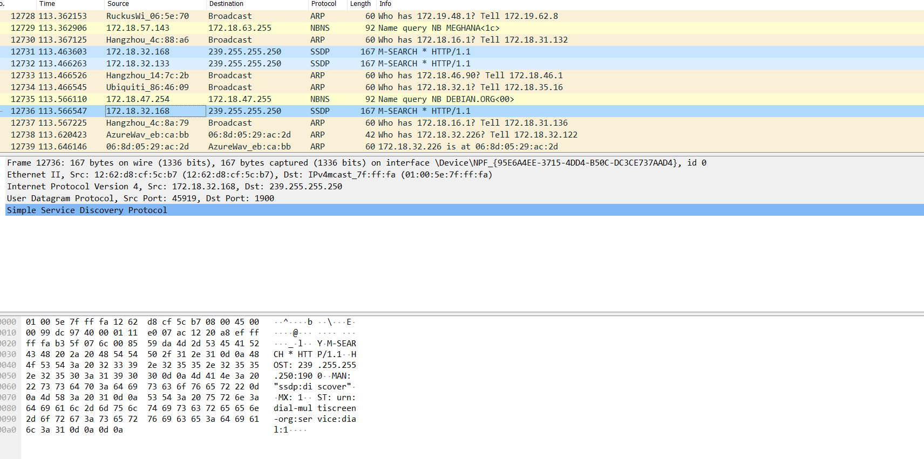

* **ICMP WIRE SHARK**

